Terminology:  Dribbling – used to advance the ball from one point to another by a single player.  Passing – a kick used to get the ball to an open teammate.  Trapping – used to stop and/or control the ball.  Direct Free Kick – the player taking the kick can score directly.  Heading – using your head to pass, score, or bring the ball to ground level.  Throw-in – used to put the ball in play from the sideline.  Tackling – used to get the ball from an opponent  Penalty area – The large rectangular area in front of the goal where the goalie is allowed to use their hands to play the ball.  Indirect Free Kick – a goal cannot be scored unless the ball has been played or touched by another player besides the kicker.  Corner Kick – a direct free kick awarded to the attacking team on the corner arc when the defending team last played the ball over their own end line  Goal Kick – taken when the offensive team touches the ball last before it crosses the end line. It is put back in play by the defensive team with a kick taken in their own goal area. All opponents must remain outside the penalty area until the kick is made and the ball is not in play until it leaves the penalty area.  One –Touch – Immediately passing the ball being received without stopping it.  Penalty Kick – a free kick awarded for a direct free kick foul in the penalty area against the defending team.  Two –Touch – Trapping the ball and then re-passing it. | 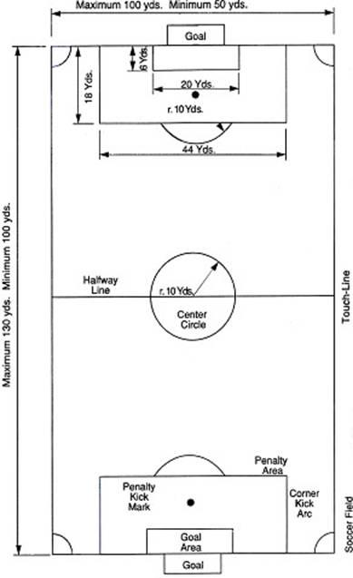

Fouls resulting in an Indirect Free Kick
An indirect free kick is one from which a goal cannot be scored unless the ball has been played or touched by another player besides the kicker.
-dangerous play
-unsportsmanlike conduct
-off sides
-attempting to kick ball while in goalie’s possession
-attempting to obstruct an opponent from playing the ball
-illegal substitution

Fouls resulting in a Direct Free Kick (the “ing” fouls)
A direct free kick is one from which the player taking the kick can score if the following occurred.
-tripping
-holding an opponent
-intentionally playing the ball with the hands
-kicking, striking, pushing an opponent
-using hands to contact the ball

Off sides: The players must be concerned with their positions in reference to the ball as play progresses. An offside penalty is called if the offensive player is closer than the defender to the opponent’s goal at the moment the ball is played. The off sides rule is for assisting the defending team so that the offensive players can’t just stand in front of the goal.

Duties of the players
There are eleven players on each side.
Goalie
Prevent the ball from entering the goal.
Forwards/Attackers (wings, striker)
Advance the ball into scoring territory and attempt to score.
Mid-fielders/Halfbacks
Work both offense and defense.
Defenders/Fullbacks (wings, stopper, sweeper)
Primarily defense: wings-outside, stopper-center, sweeper-last defender.
Prevent the opposing team from scoring

Soccer is a field game played by two teams, each consisting of 11 players. The object of the game is to put the ball into the opponent’s goal. The winning team is the one that scores the greatest number of goals.
Starting the game
A toss of the coin will decide the choice of field position of first kickoff. To begin the game, the ball is placed in a stationary position on the center spot of the field. On the referee’s whistle, the team kicking off puts the ball into play. There is no minimum distance that the ball must travel before being played a second time. Each player must be on sides (in his own half of the field) and no opponent may come into the center circle until the ball is played. The player taking the kickoff may not kick it again until another player has touched it.
After a goal is scored, the team that has been scored against restarts the game in the same manner. The second half is begun with a kickoff by the team that did not start the first half of the game.
Scoring
A goal (worth 1 point) is scored when the entire ball has crossed the goal line under the crossbar and between the goal posts, providing that the attacking team has not committed any fouls.

Throw-in
-The player taking the throw-in must face the playing field.
-The ball must be thrown with both hands, from behind and over the head.
-During the throw-in both feet must remain on the ground

Corner kick
-A corner kick is awarded to the attacking team if the ball crossed the end line and was last touched by the defending team.
-It is taken from the corner of the field and all opponents must remain 10 yards away.

