Basketball Study Guide 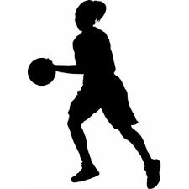
Basic Rules:  1.Players: Five players per team on the floor at a time with unlimited substitutions. Standard positions are  2 Guards, 2 Forwards, and  1 Center.  2. Offense: The team with the possession of the ball. Also Team or individual patterns of play, which are used to get the ball into scoring position.  3. Defense: The team trying to prevent the offensive team from scoring. Players may choose to play either a man to man defense (person to person) or zone. In man to man each defensive player is responsible for guarding one opponent. In a zone defense each defender is responsible for an area of the court and must guard any player who enters that area. The object of defense is to try and take the ball away, to force the other team to turn the ball over, or force them to take a low percentage shot.  Scoring: Field goals = 2 or 3 points.  Free throws = 1 point.  Timeouts: are one minute or 30 seconds in length. They can be requested during a dead ball or at any time by the team in possession of the ball. | Play:  - The game is started with a jump ball in the center circle between two opponents. In class we do not have a jump ball.  - A player is out of bounds when touching the floor on or outside the boundary line.  - The ball is out of bounds when it touches a player who is out of bounds or any other person, the floor, or any object on or outside the boundary, or the supports behind the backboard.  - When the ball is caused to go out of bounds by the last player touching it before it goes out, the opposing team will be awarded a throw-in from the spot it went out.  - While the ball is in play, an offensive player cannot remain for more than 3 seconds in the key. (the part of the free-throw lane between the baseline, the free-throw line, and the free-throw lane lines.  - If an offensive ball handler while in the front court is closely guarded by the defense for 5 seconds, a violation is called and the defense is awarded the ball.  - If two opponents are both firmly holding the ball a “jump ball” is called. A “jump ball results in an alternating possession which is kept track of at the official table. In PE, a jump ball will go to the defense.  - Violations (turnovers) include causing the ball to go out of bounds, double dribbling (picking up your dribble and then dribbling again), running with the ball, kicking the ball, striking the ball with the fist, interfering with the basket, illegal throw-in (taking more than 5 seconds or stepping on the line), being closely guarded for 5 seconds while in possession of the ball in the front court, and the 3 second lane rule.  - After one team makes a field goal or free throw the other team puts the ball into play from out of bounds under the basket at which the goal was made. Each team possessing the ball is required to advance it past the half-court line within 10 seconds after gaining possession.
Fouls:  Personal: involving pushing, charging, tripping, holding, body contact. After 5 personal fouls the player is disqualified from the game. The offended player is awarded free throws.  Technical: involving delay of game, unsportsmanlike conduct, illegal entry, excessive timeouts with the offended team being awarded two free throws and the ball out of bounds. | 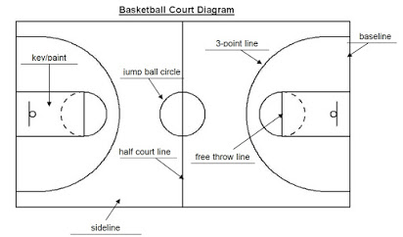
Triple Threat: 3 skills can be done from the triple threat position.  1. Shooting  2. Passing  3. Dribbling  Defensive play: 4 important things to remember.  - Stay low  2. Hands up  3. Eyes on Stomach of opponent  4. Slide feet, but do not cross them | Assist: a pass to a teammate that leads directly to a field goal.  Boxing out: a player’s attempt to position his body between his opponents and the basket to get rebounds and prevent the opponents from doing so.  Cut: a quick offensive move by a player tyring to get free/open for a pass.  Defense: preventing the offense from scoring; The Defense is considered the team without the ball  Fake: Using a deceptive move with the ball to pull the defensive player out of position.  Foul: actions by players which break the rules but are not floor violations.  Free-throw: an unguarded shot taken from the foul line by a player whose opponent committed a foul; worth 1 point.  Jump ball: where 2 opposing players jump for a ball the official tosses above and between them. The players then try to tap the ball to their teammates to gain possession.  Offense: the team with possession of the ball.  Open: when a player is unguarded by a defender.  Out of Bounds: the area outside of and including the baselines and sidelines.  Pass: when a player throws the ball to a teammate. The fastest way to move the ball.  Pivot: the foot that must remain touching the floor until a ball handler who has stopped dribbling is ready to pass or shoot.  Rebound: when a player grabs a ball that is coming off the rim or backboard after a shot attempt  Throw-in: inbounding the ball. A player has 5 seconds to pass the ball in.  Traveling: when the ball handler takes too many steps without dribbling; also called walking.  Turnover: when the offense loses possession through its own fault by passing the ball out of bounds or committing a floor violation.

